Sample Paper – 2008
Subject – Physics
Class - X

Paper 1 (Physics)
(One hour and a half)

Answers to this paper must be written on the paper provided seperately
You will not be allowed to write during the first 15 minutes
This time is to be spent in reading the question paper
The time given at the head of this paper is the time allowed for writing the answers.

Section I is compulsory . Attempt any four questions from section II
The intended marks for questions are given in brackets []

SECTION –1 (40 marks)
Attempt all questions from this section
Question –1 [ 2 x 5 = 10]
- What is an Inclined Plane. What is it’s mechanical advantage. Give one example where it is used.
- What is meant by linear momentum. What is it’s unit
- Derive relation between Power and Force .
- Is it possible to burn the piece of paper using convex lens in day light without using direct flame. Draw a diagram to support your answer
- Name an instrument used to know charged \ uncharged state of a battery .State the principal on which it works.

Question –2 [ 2 x 5 = 10]
- Define S. I. Unit of work. Express this unit in terms of basic unit ie unit of length mass and time.
- A current passes though a circular loop C What is polarity of the face of loop you are looking at What is direction of magnetic field at center of loop C?

- State Snell’s law and Write it’s limitations
- The washer man uses Indigo to the white clothes. Explain
- What is f- number of camera. on what factors does it depend?

Question – 3 [ 2 x 5 = 10]
- Explain the concave lens as a combination of prism
- Now a day modern fishing boats use a technique to locate shoal of fish. Name the technique and name type of sound used in it. What is range of wave length of sound used.
- What is Mirage. Name the phenomenon of light responsible for it.
- Name two devises in which electrical energy is changes to mechanical energy and two devices in which heat energy changes to mechanical energy.
- In a transformer 5 Amp Current at 160 Volt was supplied to primary coil; having 30 number of turns. If we need current at 240 volt then what should be number of turns in secondary coil? What will be magnitude of current. What assumption you have made to derive your answer.

Question – 4 [ 2 x 5 = 10]
- Name any four region of Electro magnetic spectrum , other than visible light in increasing order of wave length
- What do you mean by heat capacity and specific heat capacity. write relation between them
- A glass of water contain 15 gm ice and 5 gm water at 0 C .How much ice at 0C should be mixed in it to completely solidify present water? Give reason \ calculation in support your answer.
- What do you mean by non-ohmic resistance ? Draw V∼ I graph for a non-ohmic resistance. Give two examples.
- Name the material normally used as fuse wire & give at least two reason of your answer.

SECTION – II (40 Marks )
Answer any four questions from this section

Question-5 [2 +2+2 +2 +2 =10]
- Velocity time graph of a motorcyclist having mass 150 kg
Is shown in figure. Calculate Force exerted by motorcycle
in first 15 sec.[2] Force exerted by motorcycle in last 20 sec.
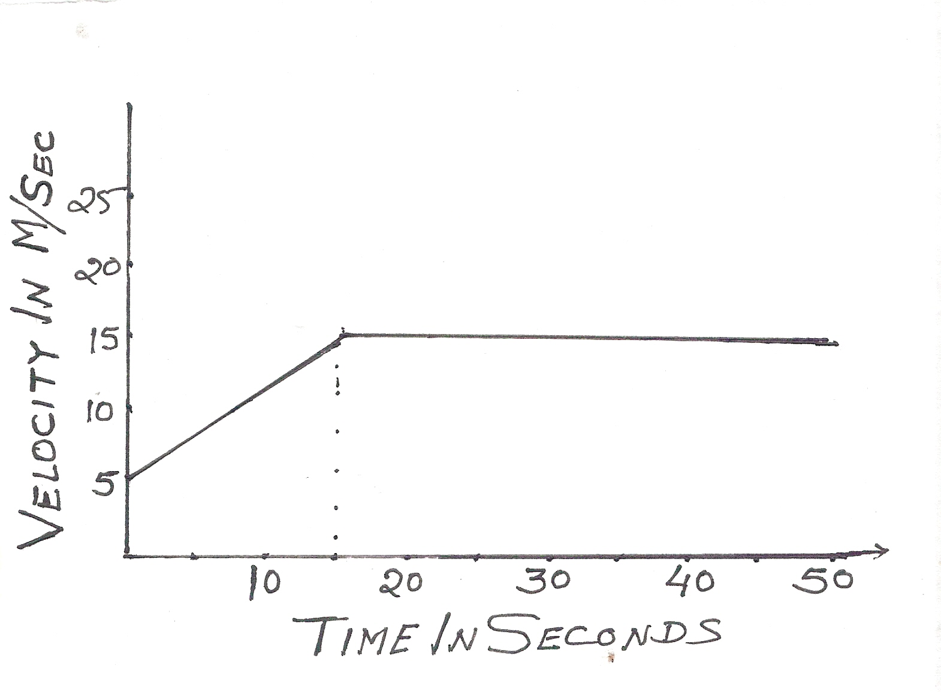

- Commonly a shopkeepers use beam balance. What
physical quantity they measure from it? Give its two
characteristics.

- The gradient of a hill road is 1: 40.Calculate weight of
vehicle whose engine pushes it up inclined road by
developing an effort of 50 N.
- A body of mass I kg is thrown upward with initial velocity of
5 m s ⁻¹ . What is magnitude of force due to gravity when it is
  - At maximum height (b) Just going to touch earth
take g = 10 M sec-2
- A fast moving cyclist continues to move uphill on a sloping road even if he do not paddles . Explain

Question-6 [ 3 +2 +2 +1 + 2 =10]
- A 1.0 kg hammer moving with a velocity of 50 m \ sec strikes an iron nail of mass 200 gm and drives it into a block of wood. If 40% energy of is wasted ie. Used in heating nail. Then what is rise in tempreture of nail? [ S.H. C. of Iron 450 J\ Kg C ]
- Why a sandy soil get heated very quickly as compared to clayey soil
- You can produce music of different note from your Sitar. What
adjustment will you make to produce sound of your desired pitch.
Explain your answer.
- If amplitude of a wave is halved what will be effect on it’s loudness
- The figure below shows a tuning fork with one of its prongs
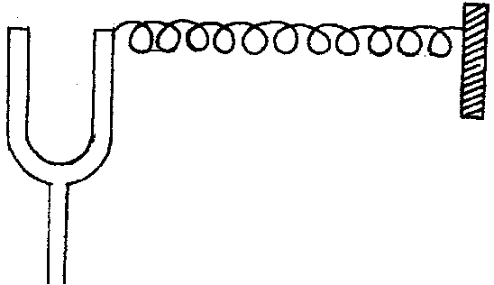
fastened to one end of a spring whose
other end is fastened to a rigid support.
When the tuning fork is made to vibrate,
how does the pattern of the coils of
the spring change?

Question - 7 [ 4 + 3+2 + 1]
- A boy uses a lens to produce an image of height 6cm on a screen. If size of object was 8 cm the what type of lens he has used? What was location of object [ In terms of Optical center ; F ; 2f etc]]Support your answer with ray diagram.
- Rohit can see near by object clearly if it is situated minimum at a distance of 1m only.[1] From what type of disease he is suffering? [2] What should be type of corrective lens? [3]Draw ray diagram before and after using the lens.
- What is effect on focal length of a convex lens if [1] Upper half is covered with a black paper[2] lens was kept in water. Give reason in support of your answer.
- Name a pair of complementary colours

Question – 8 [ 3 + 5 + 2 ]
- What is difference between single control switch and dual control switcth.Draw circuit diagram in both cases
- You have been given three resistances of 4ohm;8 ohm and 12 ohm. How will you connect these resistances to obtain an equivalent resistance of 11 ohm. if this combination is connected to a cell of 12 Volt; and internal resistence1 ohm . What is [1]Circuit current [ 2] current in 12 ohm resistance.
- What material is normally used in fuse wire? Give reason why our fuse blow?

Question--9 [ 2 + 1 +2 +4 + 1 =10]
- A pendulum vibrates at the rate of 5 vib/sec. An observer sets the pendulum to oscillate and fires a gun simultaneously. He hears the echo after 8 vibration of S.P. If velocity of sound in air is 340 m\ s, find the distance between cliff and observer.
- State two ways by which frequency of vibration of stretched string can be decreased.
- All the stringed musical instrument is provided with wooden box/air box. Explain.
- If a thermos flask contains 150 gm of ice and 30 gm of water at the same temperature. [1]Then what mass of steam at 100°c be passed to melt the ice completely.[2]What is the amount of water in the flask after all the ice melts[3] Is it possible to freeze the water, so formed by adding more ice at o C.Explain your answer.[Latent heat of ice - 336 J \ g ;Latent heat of steam - 2260 J\gm. SHC of water= 4.2 J\gm C]
- What do you understand by statement Heat capacity of a copper plate is 175 J \ per degree centigrade

Question-- 10 [ 3 + 1 +2 + 3 + 2 =10]
- What is nuclear fission ? Give an example . Write any two effect of nuclear fission.
- Name two devices in which hot cathode ray tube is used.
- Calculate energy produced when 6 micro gram of mass is converted into energy.
- Where the radio isotope C-14 is found ? How it is formed ? what is it’s practical application?
- Steam causes sever burn than the boiling water explain

