Sample Paper – 2008
Subject – Biology
Class - XI

Time : 3 hours Max.Marks 70

General Instructions:

1. All questions are compulsory.
2. This question paper consists of four Sections A, B, C and D. Section -A contains
8 questions of 1 mark each, Section -B is of 10 questions of 2 marks each,
Section -C has 9 questions of 3 marks each and Section D is of 3 questions of 5 marks each.
3. There is no overall choice .However, an internal choice has been provided
in one question of 2 marks, one question of 3 marks and all the three questions of
5 marks weightage . Attempt only one of the choices in such questions.

4. Wherever necessary, the diagrams drawn should be neat and properly labelled.

Section A

1. Identify the following cells . Where do you find them in the human body?
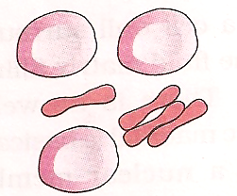 A 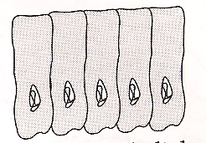B [1]

2. Why is cellulose considered a homopolymer? [1]

3. Differentiate between G1 and G2 phases of Interphase. [1]

4. A plant cell is kept in a hypotonic solution. What will happen to the solute potential
of this cell and why? [1]

5. Name the genus ,family, order and class to which Wheat belongs [1]

6. What is the economic importance of the following and to which family they belong?
[a] Indigofera [b] Colchicine [1]

7. How is the gizzard in the alimentary canal of a cockroach suitable for grinding the
food? [1]

8. The Respiratory Quotient of a substance is only 0.7 .With the help of the equation
prove it. [1]

Section B

9. Name the most widely used compound, as a source of ethylene. List its functions in tomato ,walnut and cucumber. [2]

10. In what form is potassium absorbed by the plants. Write four functions
of potassium in plants. [2]

11. Living state and metabolism are synonymous.Comment. [2]

12. 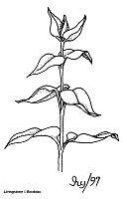 A 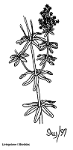 B 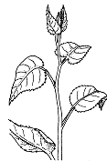 C
Name the three arrangements of leaves shown on different stems. What is it called as? Give one example of each kind. [2]

13. Two groups ( A and B ) of bean plants of similar size and same leaf area were
placed in identical conditions. Group A was exposed to light of wavelength
400 – 450 nm and Group B to light of wavelength 500 – 550 nm. Compare the
photosynthetic rate of the two groups giving reason. [2]

14. What is the technical name of fungi imperfecti ? Why is it so called? State two
characters of it and give two examples of the same. [2]

15. Experiments were carried out to investigate the action of two enzymes at different
pH values .All experiments were carried out at 37 degrees for 20 minutes.

[a] What interpretation can you draw from the graph?
[b] What happens to the pepsin reaction between pH 4 and 5 ?Why?
Observe the given graph and answer [2]

16. The given diagram shows a cell organelle. List its importance for our survival.
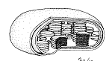 [2]

17. Write four ways by which an earthworm is economically useful. [2]

18. What is wood botanically ? Differentiate between hard and soft wood.

Or

Write the floral formula of an actinomorphic ,bisexual ,hypogynous flower with five
united sepals, five free petals, five free stamens and two united carpels with superior
ovary and axile placentation. [2]

Section C

19. The dominant phase of spirogyra is free living gametophyte whereas as in the gymnosperm the gametophyte is dependant . Illustrate the differences between the
two life cycles. [3]

20. Name the animal given below .Write its phylum and describe the general features
of the phylum.

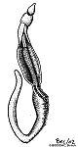 [3]

21. Based on the position of calyx ,corolla and androecium in respect of the ovary
on thalamus ,the flowers can be described in three ways. [3]

22. Connective tissues are classified into three kinds. Describe each kind. [3]

23. The diagram shows two cells : Name the part A and explain its function and structure.
Is the function and structure same in both the cells

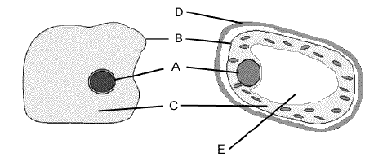

[3]

24. Organic chemists describe it as two dimensional view of the molecule ,physicists
conjure up a three dimensional view of the molecule while the biologists describe
it as a four level molecule. Which molecule is being focused on? Describe its
structure and function. [3]

25. Where does glycolysis occur in a cell? Explain its different steps.

Or

Briefly describe the fate of ammonia in plants . Give the reactions [3]

26. Define [i] Differentiation [ii] Redifferentiation [iii] Dedifferentiation.
Where do they take place? [3]

27.
Figure shows the effect of light on the rate of photosynthesis. Based on the graph,
Answer the following questions.
[a] At which point(s) ( A, B, or C) ,in the curve is light a limiting factor?
[b] What could be the limiting factor(s) in the region A?
[c] What do C and D represent on the curve?

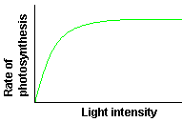 [3]

Section D

28. Why do C3 plants suffer from photorespiratory losses? Explain the mechanism of
photorespiration.

Or

Explain the formation of root nodule in a legume plant? Why is it pinkish in colour?
Give its advantage. [5]

29. Describe the events that occur during Prophase I

Or

Explain any five classes of enzymes. [5]

30. Describe the family solonaceae with floral formula and floral diagram.

Or

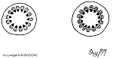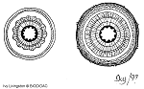
A B C D
Identify the stem and explain the process taking place in the four stages .
What is the significance of this process ? [5]

