POORNA COACHING CENTER
NEAR OLD SIVALAYAM STREET, VIJAYAWADA-01
MOBILE: 9848797758

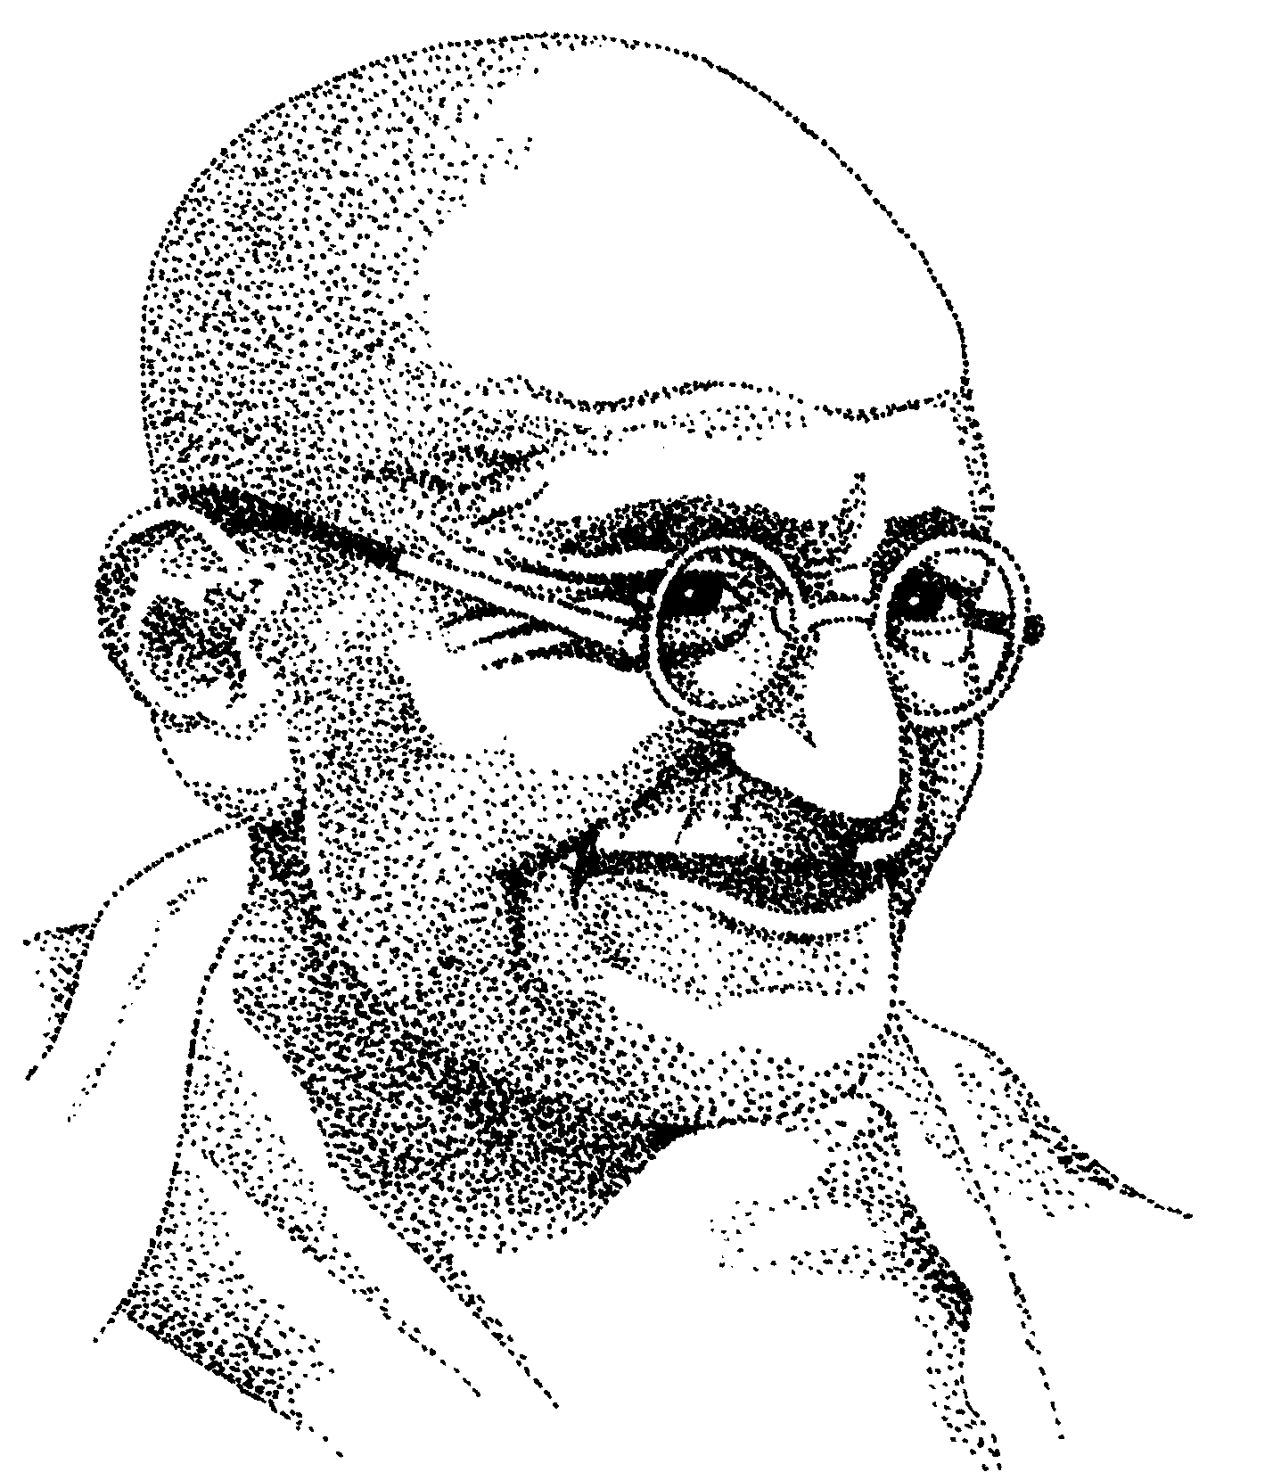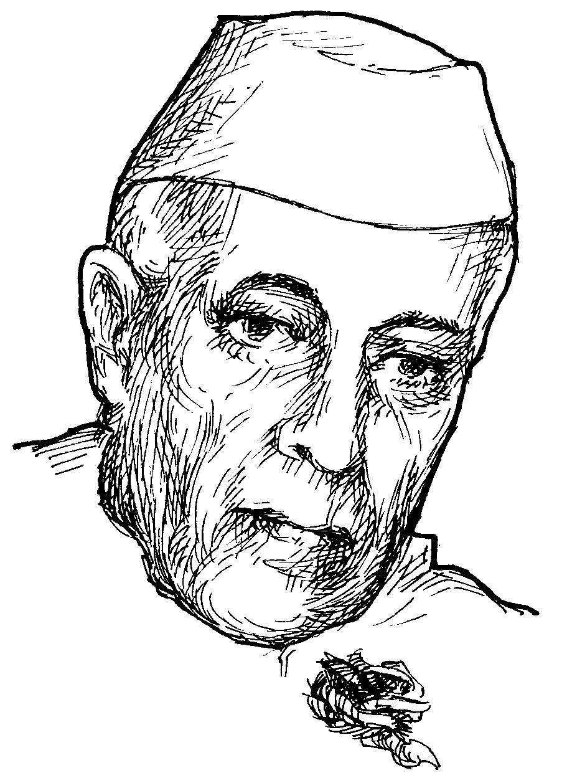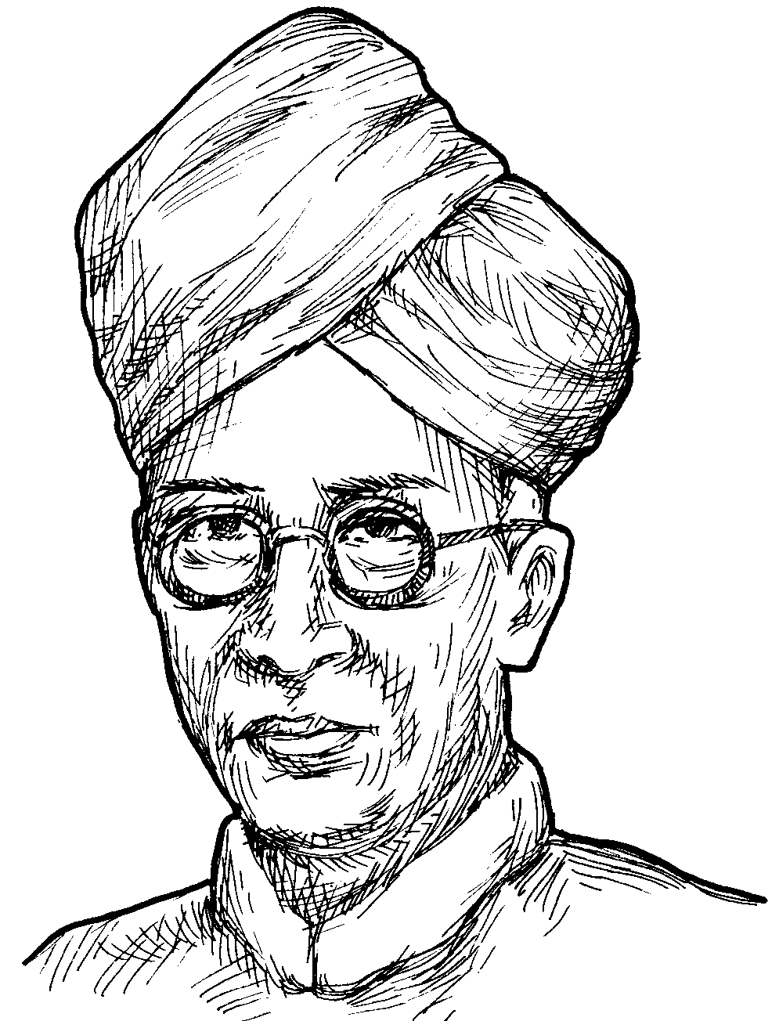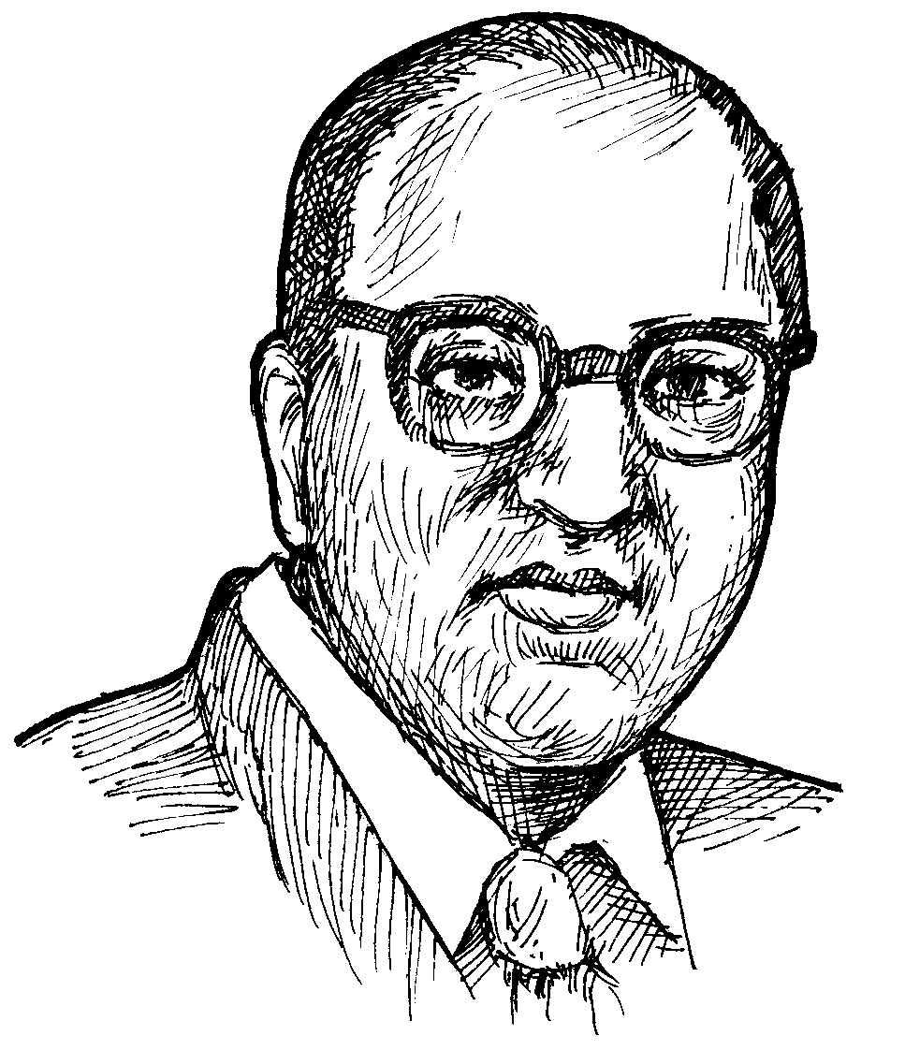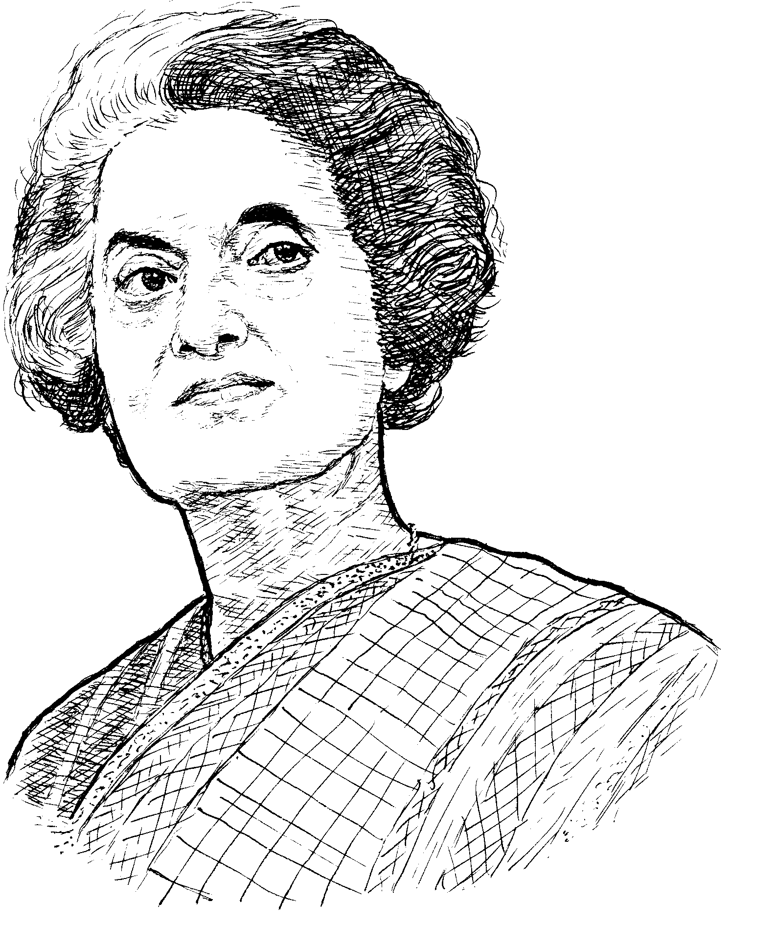

CHEMISTRY IMPORTANT QUESTIONS

CHEMISTRY: ATOMIC STRUCTURE
5M question

1. Draw the shapes of “d” orbitals.
4M questions

- Explain the important features of Rutherford’s planetary model and its defects? ( mar 05 ) (v. imp)
- State the postulates of bohrs atomic model and its drawbacks?( april-08, June 08,05,03, mar-03,00)
- Draw the diagram showing the sequence of filling the various atomic orbitals? ( June 07, mar-01 )
- State and explain with one example, the hunds rule of maximum multiplicity? ( June 07,02,00, mar-07,06 )
- Write the pauil’s exclusion principle with examples? ( mar-06)
- Define ionization energy? Mention the factors that influence it? ( june-07, mar-08,04,05) (v. imp)
2M questions

- Distinguish between between orbit and orbital? ( mar-02 )
- draw the shapes of P & S orbital ?( mar-01, June 05, June 99)
- define the terms: (a) ionization energy (v. imp)
(b) Atomic size (v. imp)
(c) Electron affinity (v. imp)
(d) Properties of principle quantum number. (V. imp)

1M questions

- Write the plank’s equation?
- What is a stationary orbit?
- What is a nodal plain?
- Explain why electron enters into 4s orbital but not 3d after filling 3p orbital?
- Define hunds rule of maximum multiplicity?
- Write the Pauli’s exclusion principle?
- Write the electronic configuration of calcium, chromium, zinc, copper, phosphorous, magnesium?
- Write the planks constant value?
- State aufbau principle?
- Define atomic radius?

CHEMISTRY: CHEMICAL BOND
5M question

- Draw the bond formation of hydrogen chloride and nitrogen molecules in a diagram ?( mar-00,99)
4M questions

- explain S-P overlap with examples?( mar-06) (v. imp)
- explain the formation of a double bond ?( june07,06; mar-01,07, June 99) (v. imp)
- Explain the formation of coordinate covalent bond? ( mar-05; june-01,02 ) (v. imp)
- Explain the formation of triple bond in nitrogen molecule? ( June 06,04,00, mar-04,02 ) (v. imp)
2M questions

- Draw the bond formation of H2 molecule ?( mar-06)
- Explain the formation of sigma and pi bonds duly showing orbital overlapping? ( mar-99)
3. Draw the shapes of the molecules (a) water (mar-05, 01, 00, june-00)
(b) Pcl3 (mar-05, 01, 00, june-00)
(c) pcl5 ( April 08, June 03,07, mar- 07, 03 )
4. Draw the diagram showing the formation of a triple bond ? ( june 08)
5. Draw the bond formation of F2 molecule? ( mar-05 )
CHEMISTRY: PERODIC CLASSIFICATION OF ELEMENTS

1M questions:
- On which atomic property is the mendleef’s periodic table base ? ( june-00 )
- which group elements can be used as strong reducing agents?( june-02 )
- explain the relationship between ionization energy and size of the molecule ?( mar-99 )
- what is oxidation ?( mar-99 )
2M questions:
- Why does the atomic radius (size) decreases from left to right in a period ?( mar-02,01,99 )
- How does the atomic radius (size) vary in a period and in a group?( mar-01,02,99 )
- How does the ionization energy vary in a period and in a group?( mar-03)
4M questions:
- Answer the following questions: ( mar-05 )
  - Define ionization energy
  - What is newlands concept of octaves?
  - What are inner transition elements?
  - What are transition elements?
- How does the atomic size and ionization energy vary in a period and in a group?( mar-02,06, 99)
- How does the following properties changes in a period and in a group: ( mar-04,06, june-06 )
  - Atomic radius ;
  - Oxidizing property;
  - Electronegativity;
  - Electropositivity;
  - Ionisation energy;

(Or)
How does the atomic properties vary in a period and in a group in a periodic table?( april-08 )
- How does the following properties changes in a period and in a group: ( june-03)
  - Electronegativity;
  - Electropositivity;
  - Oxidising nature;
  - Reducing nature;
- explain the electronic configuration of inert gases?( mar-07)
- explain the main features of long form of the periodic table?( june-07)
- what is modern periodic law? Explain its main features ? ( mar-08)

CHEMISTRY: ALKALINE EARTH METALS

1M questions:
- How many water molecules are present in Epson salt ?( june-06,04 )
- write equation showing the reaction of a alkaline earth metals with oxygen ?( mar-00,01 )
2M questions:
- Write the reaction of group11A elements with oxygen ? (mar-01,00 )
- Why do you add kcl and Nacl to Mgcl2 during “Mg” extraction ? ( june-01,05; mar-01 )
4M questions:
- write the reactions of group11A elements with 1) Oxygen; 2) Hydrogen; 3) Chlorine; 4) Water; ( mar-99,03; june-08,04,01 )
5M question:
- Draw a neat diagram showing the extraction of magnesium from its ore ? ( mar-02,06; june-02,06 )

CHEMISTRY: ACIDS-BASES AND SALTS

1M questions:
- Give the equation for the preparation of zinc hydroxide from zinc oxide? ( june-02 )
- Distinguish between an acid and base? ( june-03 )
- What is Arrhenius theory? ( march-06 )
- Distinguish between H+ and [ H+ ]? ( june-99 )
- what is ionic product of water ? ( mar-07,04,02,01,99, june-08,00 )
- define pH ? ( mar-99,05, june-01,05 )
- Calculate the pH of 0.001M HCl ? ( april-08, march-01 )
- Calculate the pH of 0.002M HCl ? ( march-99 )
- Give a limitation of Arrhenius theory ? ( june-07 )
- What is the ionic product of water at 25`C ? ( march-07 )
- Define Heat of Neutralization? ( march-08 )
2M questions:
- Write two chemical properties of acids with equations? ( june-04 )
- Define the heat of Neutralization? Give one example. Give its value for a reaction between a strong acid and base? ( june-06, march-00,03 )
4M questions:
- Write shorts notes on ( june-00,02,05 )
  - Limations of Arrhenius theory of acids and salts?
  - The Heat of Neutralisation .
- Define pH value? Calculate the pH value of 0.002M Hcl. ( march—99)
- Write shorts notes on ( june-01 )
  - pH
  - Strength of acids and bases
- Define the terms ( march-02 )
  - Strong acid
  - Strong base
  - Weak acid
  - Weak base

CHEMISTRY: CHEMISTRY OF CARBON COMPOUNDS

1M questions:
- What is the allotropy? ( june-03,00 )
- What is catenation ? ( march-03, june-00 )
- What is Polymerisation ? ( june-06, march-04 )
2M questions:
- Why does diamond acts as a bad conductor of electricity ? ( june-99 )
- Draw the structure of Benzene? ( march-00 )
- Distinguish Between Alkalnes and Alkenes ? ( march-03 )
- Write the chemical equation for the addition reactions of alkenes with H2 and Cl2. ( june-01 )
4M questions:
- Compare the structure of diamond and Graphite? ( june-03 )
- What are Alkanes? Write the Substitution reactions and combustion reactions? ( march-01; june-04 )
- Give the reactions of CH4 ( methane ), with Cl2 ( chloride ) in the presence of sunlight in four stages with the balanced equations? ( june-05 )

CHEMISTRY: CARBOHYDRATES AND PROTEINS

1M questions:
- What is sulphitation? ( june-03 )
2M questions:
- How is glucose tested with ( june-02 )
  - Tollen’s reagent
  - Benedicts reagent
- How do you perform ( march-02 )
  - Tollen’s test
  - Benedicts test for detecting sugar.
- How do you prepare Benedicts solution? ( june-03 )
- What are amino acids? Give two examples? ( june-06, 04 )
4M questions:
- What are the main steps involved in the Production of sugar from sugarcane? Mention the important by- product and its use? ( march-00 )
- What are proteins? How does a peptide bond form? Mention the important function of protein? ( march-02, june-99 )
- Describe the different steps involved in the manufacture of sugar? ( march-00 )
5M questions:
- Draw a suitable diagram showing various steps involved in the manufacture of sugar? ( march-01,04,06,07 )
- Draw a chart showing alcohol manufacture? ( april-08, mar-08,05,03, june-08,05,01,00 )

CHEMISTRY: OILS AND FATS

1M questions:
- What are the advantages of hydrogenation of oil? ( june-02, march-04 )
- What is Saponification? ( june-05, march-02 )
- Why do shaving soaps give slow drying laner? ( march-00 )
- What is a soap? ( march-07 )
2M questions:
- Write the industrial uses of oil? ( june-01 )
- Distinguish between a soap and a detergent? ( march-99 )
4M questions:
- How do you test the quality of a soap? ( april-08, june-06,07,mar-01,02,05,07,june-99 )
- Write the uses of a soap? ( june-06 )
- What are detergents? Explain the steps involved in the manufacture of detergent? ( march-02,06, june-00 )
- How is soap industrially manufactured? ( june-08 )
- What are the differences in the manufacturing of a soap and detergent? ( march-08 )
5M questions:
- Draw a neat sketch of hydrogenation of oils and label its parts? ( june-03 )

CHEMISTRY: CHEMISTRY AND INDUSTRY

1M questions:
- What are the primary Nutrients? ( mar-06 )
- What is the use of Microfertilizers? ( april-08,mar-05,00 )
- What are Adhesives? ( march-04 )
- Mention names of any two chromophores? ( june-04 )
- What is the use of adding cullet to the raw materials of glass? ( march-08, june-07 )
- What is Plastic? ( june-08 )
2M questions:
- Mention the methods of manufacture of cement ? ( march-06 )
- What is Annealing? ( march-07, june-05 )
- Define and give two examples for each ( march-05 )
  - Cosmetics
  - Pharmaceuticals
- Describe briefly coldcream and face powder mentioning their ingredients. ( march-99 )
- Sketch the structure of Asprin drug molecule? ( april-08, june-07,04,05 )
- Sketch the structure of Paracetamol drug molecule? ( june-02 )
- Write shorts notes on Poltery ? ( march-07 )
- What are the uses of Cold-cream ? ( june-07, march-07 )
- What are the characteristics of good quality face powder? ( june-08, march-08 )
4M questions:
- Write shorts notes on ( march-07, june-01 )
  - Synthetic adhesives uses
  - Pottery and earthen ware?
- What is a drug? How are they classified as per therapeutic action? ( march-00,04 )
- What is a drug? What are the requisiting of an ideal drug? List out the sources of drugs? ( march-03, june-06, june-99 )
- What is fractionation ? describe about petroleum fractionation of petroleum? ( june-03 )
- What are fertilizers ? Discuss their types with examples? ( march-99 )

LIST OF SHORTS: CHEMISTRY
- state the Aufbau principle?
- What is the ionic product of water?
- What is plastic?
- Define Atomic radius?
- What is the use of adding cullet to the raw material of glass?
- Define Heat of Neutralization?
- Write the electronic configuration of calcium (Ca), Chromium (Ch )?
- Calculate the pH of 0.001M Hcl?
- What is the use of micro fertilizers ?
- Define electron affinity?
- Give a limitation of Arrhenius theory ?
- What is the use of adding cullet to the raw materials of glass?
- Write the plank’s equation. What is the value of plank’s constant?
- What is the value of ionic product of water at 25C ?
- What is Annealing?
- How many water molecules are present in Epson Salt?
- What is polymerization?
- What is Hund’s principle?
- What is an Arrhenius acid?
- What are the Primary Nutrients?
- Write the Pauli’s exclusion principle ?
- What is meant by Saponification?
- Define pH ?
- What is the use of micro-fertilizers ?
- Explain why electron enter into 4s orbital but not 3d after filling 3p orbital?
- Mention names of any two Chromophores?
- What is sulphitation ?
- What is Allotropy?
- Write any two differences between Acids and Bases?
- What are the advantages of Hydrogenation of oils?
- Which group of elements in a periodic table can be used as reducing reagents?
- Write down the balanced equation showing the preparation of zinc hydroxide from Zinc oxide?
- Draw the shape of Ammonia molecule?

