POORNA COACHING CENTER
NEAR OLD SIVALAYAM STREET, VIJAYAWADA-01
MOBILE: 9848797758

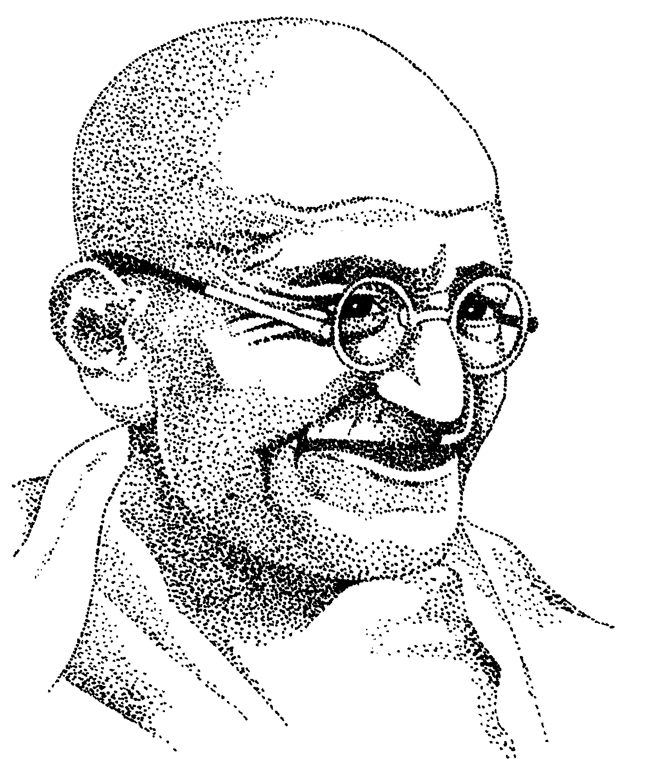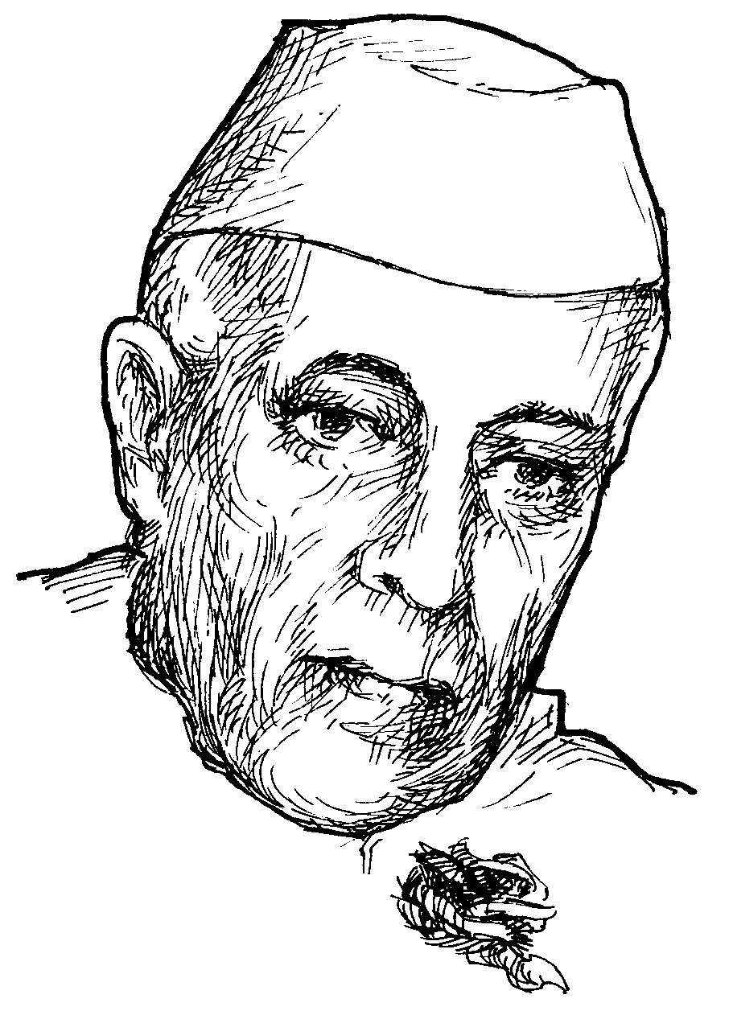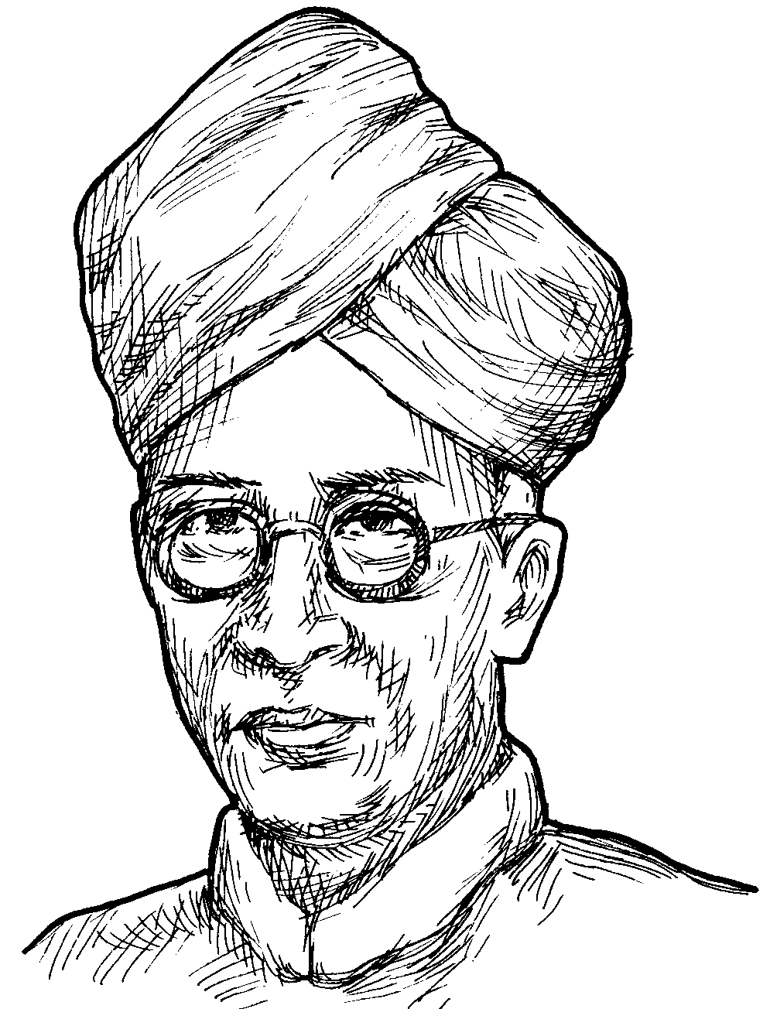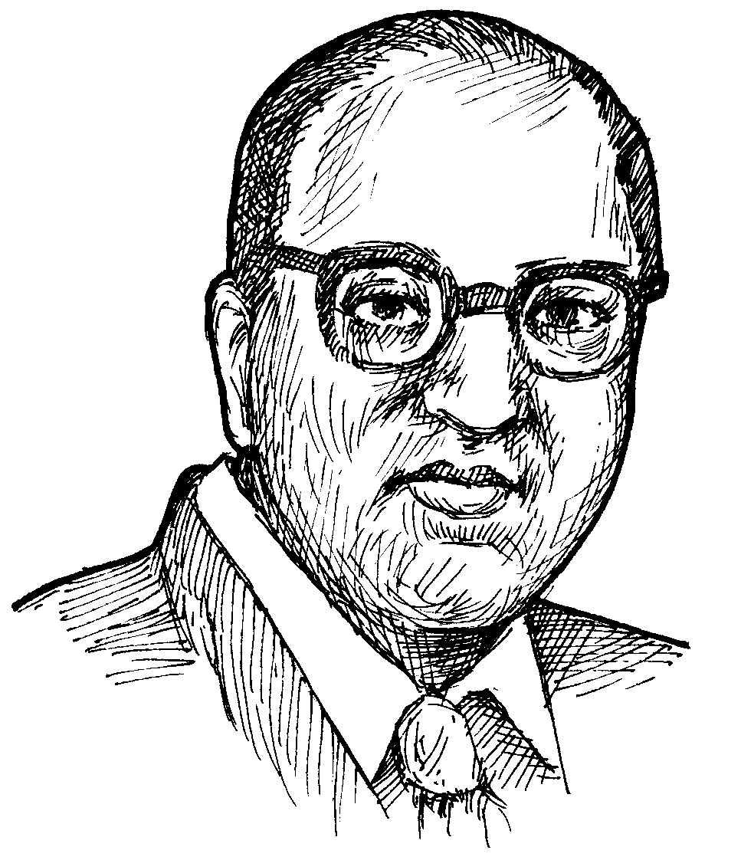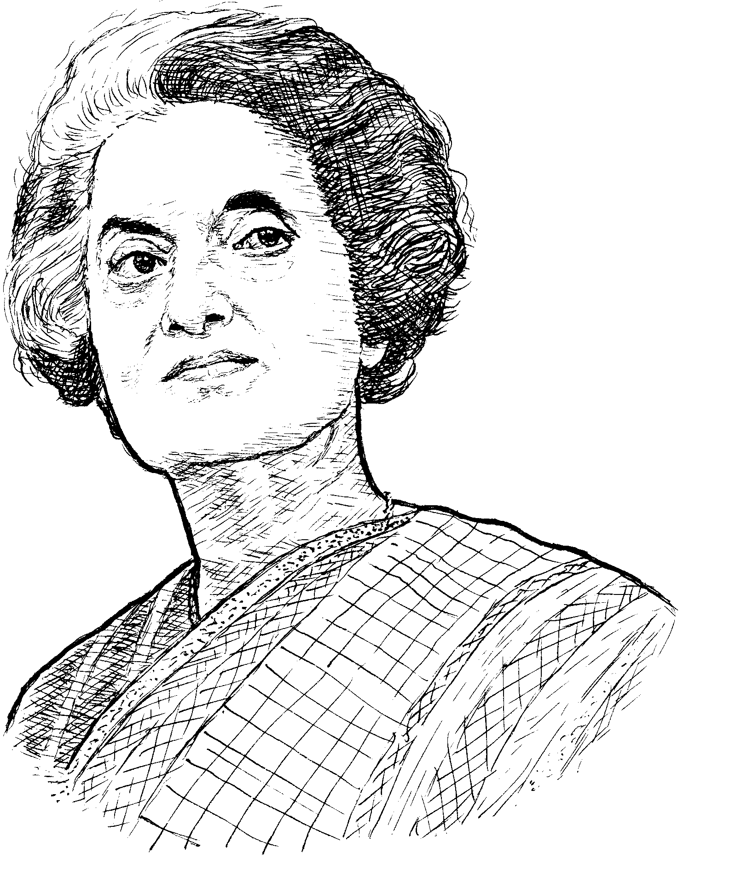

PHYSICS IMPORTANT QUESTIONS

PHYSICS: MEASUREMENT OF LENGTH
1M questions:
- Define least count of a screw gauge? (mar-01)
2M questions:
- What is the principle of a screw gauge? ( mar-00,03 )
4M questions:
- How do you determine the diameter of a wire using a screw gauge?
- What are the positive and negative zero errors of a screw gauge? How are they determined?
5m questions:
- Draw the neat sketch of screw gauge and label its parts?
- Draw the diagrams showing zero errors of a screw gauge. (a) No zero error; (b) negative error (c) positive error.

PHYSICS: OUR UNIVERSE – GRAVITATION

1M questions:
1. WHAT IS HELIOCENTRIC THEORY? MAR-05
2. WHAT IS ACCELERATION DUE TO GRAVITY? APRIL-08, MAR-06
3. STATE HOOKES LAW? MAR-04
4. DEFINE THE WEIGHT OF A BODY? MAR-07
5. DEFINE THE MASS OF THE BODY? JUNE-08
6. WHY “g” VALUE DECREASES WHEN WE GO DEEP INTO THE EARTH? MAR-08
2M questions:
1. STATE THE NEWTON LAWS OF THE UNIVERSAL GRAVITION. CALCULATE THE GRAVITATIONAL FORCE ON AN OBJECT OF MASS 10kg? MARCH-03, 02.
2. DERIVE THE RELATION BETWEEN ACCELERAATION DUE TO GRAVITY AND UNIVERSAL GRAVITATIONAL CONSTANT? JUNE-02, 05, 07
3. DIFFERENTIATE BETWEEN MASS AND WEIGHT OF A BODY? JUNE-03, 04, 06
4. WHAT ARE THE FACTORS THAT INFLUENCE THE VALUE OF “g”? JUNE-08

PHYSICS: DYNAMICS
1M questions:
1. What is the principle of launching a satellite into an orbit? (June-00, 04, mar-01)
2. Give examples for oscillatory motion observed in your day-to-day life? (June-00)
2M questions:
- what is the angular velocity of the earth about its own axis ?( june-99)
- Distinguish between a rotatory motion and a circular motion? ( march-06)
- What is a centrifuge? How does it work? Give one domestic example where the principle of centrifuge is involved?( april-08,mar-99,04,june-04)
- explain the working of a laundry drier?(mar-05,03,07,june-07)
- what is the necessity for banking of roads?(june-04)
- state the characteristics of a SHM?( june-05)
- find the length of a the simple pendulum whose time period is 1.8 seconds?( mar-99)
- What is SHM? What are its characteristics?( june-08 )
4M questions:
- distinguish between centripetal and centrifugal forces?( mar-02,june-08,02,03 )
- derive the formula of the banking angle tan 0 = v ^2 / rg ?( june-01,02 )
- describe an experiment to determine the acceleration due to gravity by a simple pendulum?( mar-00)

PHYSICS: ELECTROMAGNETIC SPECTRUM

1M questions.
- What is the reason of depletion of ozone layer in atmosphere?( june-06, mar-00 )
- What are the uses of hard x-rays?( june-01 )
- What is radiography?( mar-03 )
2M question:
- Draw the diagram of electromagnetic waves? ( mar-01, june-05 )
5M question:
1. Draw and label the diagram showing various regions of electro-magnetic spectrum and their wavelength ranges? (Mar-06)

PHYSICS: SOUND

1M questions:
- define resonance?( mar-08,02,05, june-08,05 )
- mention few incidents of resonance phenomenon observed in your daily life?( june-01, mar-01, mar-99)
- Draw a figure showing the formation of a stationary wave? ( june-99 )
- Distance between a node and the next antinodes in a stationary wave are 10 cms. Find the wavelength? (april-08, mar-03 )
- What is the resonating air column? ( mar-06 )
- In a resonating air column experiment with a closed end tube, the first resonance occurs when the length of the air column is 10cm. find out the length of the air column for the occurrence of the second resonance?( mar-04 )
- what is damped vibrations?( mar-07 )
2M questions:
- Distinguish between node and antinodes? ( mar-00, june-07 )
4M questions:
- Describe the experiment to find the velocity of air by resonating air columns?( june-05 )
- Distinguish between- progressive and stationary waves?( mar-02, june-01 )
- Describe a method to determine the velocity of sound in air? ( june-00,04,06 )

PHYSICS: LIGHT-NATURE OF LIGHT AND SOURCES OF LIGHT & VISUAL PHOTOMETRY AND LASERS

2M questions:
- What are the basic processes involved in the working of a laser? ( mar-01 )
- How do you distinguish laser light from an ordinary light in terms of the property of coherence? ( mar-99 )
- Write the applications of lasers in medicine? ( june-03,06 )
4M questions:
- Give a comparison between Newton’s corpuscular theory and wave theory? ( june-08, april-08, mar-03,05, june-99 )
- Describe the Ripple tank. How does it help in understanding reflection and refraction of light? ( june-07, mar-02,99 )
- What are the important applications of laser light in science and technology? ( mar-06,04, june-04,02 )
- Explain the main parts of laser?( mar-07 )
- What are the important applications of LASER light in medicine, industry and space science? ( mar -08 )

PHYSICS: MAGMETISM

1M questions:
- What is meant by Magnetic moment? ( june-05,00 )
- Define Ferro magnetic substance? ( june-03,00 )
2M questions:
- State and explain inverse square law of magnetism? ( june-00,mar-06,04 )
- Draw a neat diagram of magnetic lines of force, when S-pole of a bar magnet faces geographical north, locate the null points?( june-02,01,june-99 )
- Calculate the magnet moment of a short bar magnet of length 5cm and pole strength 2*10^-3? ( april-08,mar-05 )
- Define the following terms: ( mar-02 )
  - Magnetic susceptibility;
  - Magnetic permeability;
- What are the values of magnetic induction at a distance ‘d’ as the axial line and on the equatorial line of a bar magnet ?( march-07 ))
- Calculate the value of magnet induction at a distance of 0.5m on the axial line of a short bar magnet of length 5cms and pole strength 2*10^-3 m? ( june-08 )
- Explain why ferromagnetic substance like iron rod is a not a magnet by itself? Explain on the basis of Domain theory?( march-08 )

4M questions:
- What are the essential ideas of the Ewing’s molecular theory of magnetism? What are the reasons for its failure ?( march-02 )
- Explain the dia, para, and Ferro magnetic substances. Give examples of each type ?( march-99 )
- Distinguish between Dia magnetic and para magnetic substances ?( june-00 )
- Define the following terms: ( mar-01,04, june-04,06,07 )
  - Magnetic susceptibility;
  - Magnetic permeability; compare the values of relative permeability and magnetic susceptibility of Dia, para, and Ferro magnetic substances?
5M questions:
- Draw a neat diagram of a magnetic lines of forces, when N-pole of a bar magnet facing geographical north locate the null points? ( mar-03, june-05 );

PHYSICS: ELECTRICITY

1M questions:
- Draw a common electric circuit and label the parts? ( mar-99 )
- What is the total e.m.f when three cells of voltages 1v, 1.5v, and 2v are connected in series?( mar-01 )
- The resistance of magnetism wire of 1mm^2 cross sectional area is 15 ohms. Find the resistance of the maganin wire of the same length but of cross-section of 3mm^2 ?( june-01 )
- Calculate the equivalent resistance of two resistors of 6 ohms and 4 ohms connected in parallel? ( june-03 )
- What is the difference between A.C motor and D.C motor? ( mar-00 )
- What is a Transformer ? On what principles does it work?( june-00, mar-02,00 )
2M questions:
- Calculate the equivalent resistance of two resistors 100 ohms and 1 ohm connected in parallel?( june-02)
- State A) Joule’s Law; B) Flemings Right Hand Rule;( june-01 )
- State the First Law and Second Law of Electrolysis?( june-03 )
- State and Explain Lenz’s law ?( june-05,02, mar-02,03 )
- State the Laws of resistance?( mar-07)
- Explain the process of electrotyping?( mar-08)
4M questions:
- State Ohm’s law. Describe an experiment to verify Ohm’s law? ( mar-05,01 )
- What are the Ohmic and non-ohmic conductors? Give examples . Find resistance of the bulb when the potential difference across is 240v. when a current of 3A flows through it?( june-01 )
- Derive p=RA / l; write their units? ( june-00 )
- Show that effective resistance of a series of combination in a circuit is equal to the sum of the individual resistance? (or) Derive R=R1+R2+R3; ( june-06, mar-06,04 )
- Derive an expression for equivalent resistance of parallel combination of three resistance R1, R2, and R3 ? (or) Derive 1/R=1/R1+1/R2+1/R3; ( april-08) ( june-06, march-06,04 )
- Define Joule’s law and derive Q=i^2 RT / J? ( june-02,03, march-08 )
- An electric installation of 100 lamps each drawing 0.2 amp at 220v supply. Find the cost of working of installation for a month of 30 days at 5 hours per day, if the energy used is charged at the rate of Rs. 2/- per unit? ( march-07, june-05 )
- A House is fitted with 10 lamps of each 60 watt. If each lamp burns 5 hours a day, find the cost of consumption in a month off 30days at the rate of Rs. 2.40 perunit? ( june-04)
- Derscribe an experiment to verify faraday’s second law of electrolysis. Mention any two application of electrolysis?( march-99,03 )
- Deduce the relationship V1/V2 = I2/I1 ; for Transformer? ( june-99 )
- Explain the construction of a transformer with a neat diagram? ( june-08 )
5M questions:
- Draw a neat diagram of Electric Motor and Label Its Parts?( june-00 )

PHYSICS : MODERN PHYSICS

1M questions:
- Distinguish between atomic mass and atomic number ?( march-99 )
- Define the term ‘mass defect’?( june-06,march-06,04 )
- The mass defect. When helium nucleus is formed is 0.0303 amu.Calculate the binding energy?( june-02)
- what is binding energy ?( march-02 )
- state the law of radio active disintegration?( april-08,march-08,june-04 )
- what are isobars? Explain with examples ? ( march-05 )
- mention the isotopes of “Na”?( march-07 )
2M questions:
- Distinguish between Natural radio activity and Artificial radio activity? ( june-99 )
- Explain the process of Beta – decay with an example? ( june-03 )
- What are isotopes? ( march-07,03, june-00 )
- What is Artificial transmutation? Give an example. ( june-04 )
- What is the function of moderator in a nuclear reactor? ( june-00,07 )
- What is a Moderator? Give an example. ( june-05 )
- What is nuclear fusion? Give an example with the equation? ( march-99 )
- Mention the uses of radio isotopes in industry? ( march-02 )
4M questions:
- Describe the Rutherford gold foil experiment with a diagram ? mention its importance? ( mar-00 )
- Calculate the mass defect in the formation of 2[He]4 ; How do you account for mass defect of an atom? ( june-99 )
- What is the mass defect and binding energy of 8[O]16; when its nuclear mass is 15.995 amu? ( mar-00 )
- Compare the properties of alpha, beta, and gama radiations? ( april-08, june-05 )
- What is chain reaction? How is a chain reaction controlled in a Nuclear Reactor? ( march-07,05,06, june-01,03 )
- What are the uses of Radio isotopes? ( june-08 )
- Explain with a neat diagram, the emission of radiations from a radio-active substance? ( march-08 )

5M questions:
- Draw the Rutherford gold foil diagram and label its parts? ( june-06 )
- Sketch the diagram of a nuclear Reactor showing various parts? ( march-00, 02,04, june-02 )

PHYSICS: ELECTRONICS
1M questions:
- Draw the symbol of “ p-n-p “ transistor?
- Define a Byte?
- What is a hole?
2M questions:
- What is the effect of Temperature on the energy gap of a semi-conductor? ( march-06 )
- Define the terms (june-99 )
  - Electron current
  - Hole current
- What is Doping?( april-08,june-06, mar-04,00 )
- Draw the symbols of “ p-n-p “ and “ n-p-n “ transistor?( june-08, mar-05, june-01 )
- Draw a neat diagram of “p-n “ junction diode: ( june-04 )
  - Forward bias condition
  - Reverse bias condition
- What are Hardware and Software of a computer?( march-05,07, june-07 )
- Draw the block diagram of a computer?( april-08, mar-06 )
- Distinguish between a machine language and a high level language?( june-02 )
- How important is a computer in a modern day-life?( june-01 )
- What are the uses of junction transistor? ( mar-05 )
4M questions:
- How do you classify the solids electrically? ( june-07,00 )
- Explain the following : ( june-03 )
  - Extrinsic semi-conductor;
  - Doping;
  - Transistor;
  - Energy bond;
- Explain the formation of p-type and n-type semi-conductors? ( june-08,march-06 )
- State the properties and uses of a junction diode? ( april-08, march-05 )
- What is a transistor ? describe two types of transistors with the help of diagram? ( march-07, june-05 )
- State the properties and uses of a junction transistor? ( march-07, 03 )
- Explain the different stages of Radio-communication with a diagram?( march-00 )
- Explain the different stages of TV communications with the help of diagram?( march-04, june-04 )
- Draw the Block diagram of a computer. Describe briefly the functions of the components? ( mar-08,06,01, june-02 )
5M questions:
- Draw the sketches of the formation of p-n junction diode with the depletion region? ( june-99 )
- Draw different stages of TV communication with a block diagram? ( june-04, march-04 )

LIST OF SHORT ANSWERS: PHYSICS

- Define the weight of a body?
- Define the mass of the body?
- What is acceleration due to gravity?
- Explain the phenomenon of resonance?
- What is a hole?
- why “g” value decreases when we go deep into the earth?
- what is Resonance? ( v. imp )
- State the Law of Radio-active Decay?
- what is acceleration due to gravity?
- What is the wave length of a stationary wave in which the distance between the node and the antinode is 10cms?
- state the law of Radio-active disintegration?
- state the hookes law?
- define nodes and antinodes?
- what is the function of moderator in a nuclear reactor?
- mention the isotopes of Ne?
- what is damped vibration?
- A ball is thrown up and attains a height of 80mts. Find its initial speed?
- Define the mass defect? ( v. imp )
- What is the reason of Depletion of Ozone layer in atmosphere?
- What is resonating-air column?
- Find the velocity of a freely falling body from a height of 20m when it touches the ground.[g=10m/s;]
- What is magnetic Moment?
- what is heliocentric theory?
- what are isotones?
- A ball is thrown up and attains a maximum height of 80m. find its initial speed?
- What is principal of launching a satellite into a orbit?
- Ina resonating-air column experiment with a closed-end tube, first resonance occurs when the length of the air-column is 10cm. find out the length of the air-column for the occurrence of second resonance?
- Caculate the equivalent resistance of two resistors of 6 ohms and 4 ohms connected in parallel?
- what is isobars? Give one example?
- what is ferromagnetic substances? Give an example?
- Define Byte?
- What is Radiography?
- Distance between a node and the next antinode in a stationary wave is 10cms. Find the wavelength?
- “ The weight of the body is not the same on the surface of the earth at all places”. Specify the reason?
- Define the Lenz’s law?
- The mass defect, when Helium nucleus is formed, is 0.303 amu .Calculate the binding energy?
- On what principals does a transformer works?
- What is binding energy?

