MOTHER TERESA WOMEN’S UNIVERSITY
KODAIKANAL

DIRECTORATE OF DISTANCE EDUCATION

UNDER GRADUATE, DIPLOMA & CERTIFICATE COURSES

CALENDAR YEAR & ARREAR EXAMINATIONS

TIME TABLE – DECEMBER 2011

Bachelor of Business Administration – I Year & Arrear
Date | Paper Code | Title of the Paper | Time
07.12.2011 | DBTA1/DBHI1 | Part I-Tamil/Hindi | 10.00 – 1.00
08.12.2011 | DBEN1 | Part II – English | 10.00 – 1.00
09.12.2011 | DBBA1 | Business Communication and Office Automation | 10.00 – 1.00
10.12.2011 | DBBA2 | Business Economics and Business Environment | 10.00 – 1.00
12.12.2011 | DBBA3 | Financial Accounting and Management Accounting | 10.00 – 1.00

Bachelor of Business Administration – II Year & Arrear
Date | Paper Code | Title of the Paper | Time
07.12.2011 | DBBA4 | Principles of Management | 2.00 – 5.00
08.12.2011 | DBBA5 | Company Law and Business Law | 2.00 – 5.00
09.12.2011 | DBBA6 | Organizational Behaviour | 2.00 – 5.00
10.12.2011 | DBBA7 | Banking Theory Law and Practice | 2.00 – 5.00
12.12.2011 | DBBA8 | Business Statistics and Business Mathematics | 2.00 – 5.00

Bachelor of Business Administration – III Year & Arrear
Date | Paper Code | Title of the Paper | Time
13.12.2011 | DBBA9 | Research Methodology | 10.00 – 1.00
14.12.2011 | DBBA10 | Ent Entrepreneurship Development | 10.00 – 1.00
15.12.2011 | DBBA11 | Marketing Management | 10.00 – 1.00
16.12.2011 | DBBA12 | Financial Management | 10.00 – 1.00
17.12.2011 | DBBA13 | Cost Accounting | 10.00 – 1.00

Bachelor of Computer Applications – I Year & Arrear
Date | Paper Code | Title of the Paper | Time
07.12.2011 | DBTA1/DBHI1 | Part I-Tamil/Hindi | 10.00 – 1.00
08.12.2011 | DBEN1 | Part II – English | 10.00 – 1.00
09.12.2011 | DBCA1 | Discrete Mathematical Structures | 10.00 – 1.00
10.12.2011 | DBCA2 | Programming in C | 10.00 – 1.00
12.12.2011 | DBCA3 | Digital Principles and Computer Organization | 10.00 – 1.00

Bachelor of Computer Applications – II Year & Arrear
Date | Paper Code | Title of the Paper | Time
07.12.2011 | DBCA4 | Resource Management Techniques | 2.00 – 5.00
08.12.2011 | DBCA5 | Programming in C++ | 2.00 – 5.00
09.12.2011 | DBCA6 | Visual Programming | 2.00 – 5.00
10.12.2011 | DBCA7 | Relational Database Management System | 2.00 – 5.00
12.12.2011 | DBCA8 | Systems Programming | 2.00 – 5.00

Bachelor of Computer Applications – III Year & Arrear
Date | Paper Code | Title of the Paper | Time
13.12.2011 | DBCA9 | Computer Oriented Numerical Methods | 10.00 – 1.00
14.12.2011 | DBCA10 | Programming with Java | 10.00 – 1.00
15.12.2011 | DBCA11 | Computer Graphics & Multimedia | 10.00 – 1.00
16.12.2011 | DBCA12 | Computer Networks | 10.00 – 1.00
17.12.2011 | DBCA13 | Software Engineering | 10.00 – 1.00
19.12.2011 | DBCA14 | Accounting and Financial Management | 10.00 – 1.00

B.Com – I Year & Arrear
Date | Paper Code | Title of the Paper | Time
07.12.2011 | DBTA1/DBHI1 | Part I-Tamil/Hindi | 10.00 – 1.00
08.12.2011 | DBEN1 | Part II – English | 10.00 – 1.00
09.12.2011 | DBCO1 | Managerial Economics | 10.00 – 1.00
10.12.2011 | DBCO2 | Business Correspondence and Office Automation | 10.00 – 1.00
12.12.2011 | DBCO3 | Financial Accounting - I | 10.00 – 1.00

B.Com – II Year & Arrear
Date | Paper Code | Title of the Paper | Time
07.12.2011 | DBCO4 | Marketing and E-Commerce | 2.00 – 5.00
08.12.2011 | DBCO5 | Business Statistics and Mathematics | 2.00 – 5.00
09.12.2011 | DBCO6 | Banking Law and Practice | 2.00 – 5.00
10.12.2011 | DBCO7 | Entrepreneurship Development & Women Empowerment | 2.00 – 5.00
12.12.2011 | DBCO8 | Financial Accounting - II | 2.00 – 5.00

B.Com – III Year & Arrear
Date | Paper Code | Title of the Paper | Time
13.12.2011 | DBCO9 | Principles and Practice of Auditing | 10.00 – 1.00
14.12.2011 | DBCO10 | Business Law | 10.00 – 1.00
15.12.2011 | DBCO11 | Corporate Accounting | 10.00 – 1.00
16.12.2011 | DBCO12 | Income Tax Law and Practice | 10.00 – 1.00
17.12.2011 | DBCO13 | Cost & Management Accounting | 10.00 – 1.00

B.A.English – I Year & Arrear
Date | Paper Code | Title of the Paper | Time
07.12.2011 | DBTA1/DBHI1 | Part I-Tamil/Hindi | 10.00 – 1.00
08.12.2011 | DBEN1 | Part II – English | 10.00 – 1.00
09.12.2011 | DBAE1 | British Literature | 10.00 – 1.00
10.12.2011 | DBAE2 | History of English Literature | 10.00 – 1.00
12.12.2011 | DBAE3 | Journalism | 10.00 – 1.00

B.A.English – II Year & Arrear
Date | Paper Code | Title of the Paper | Time
07.12.2011 | DBTA2/DBHI2 | Part I-Tamil/Hindi | 2.00 – 5.00
08.12.2011 | DBEN2 | Part II – English | 2.00 – 5.00
09.12.2011 | DBAE4 | William Shakespeare | 2.00 – 5.00
10.12.2011 | DBAE5 | American Literature | 2.00 – 5.00
12.12.2011 | DBAE6 | Literary Forms & Criticism | 2.00 – 5.00

B.A.English – III Year & Arrear
Date | Paper Code | Title of the Paper | Time
13.12.2011 | DBAE7 | English for Practical Purposes | 10.00 – 1.00
14.12.2011 | DBAE8 | 20th Century Literature | 10.00 – 1.00
15.12.2011 | DBAE9 | English Language Teaching | 10.00 – 1.00
16.12.2011 | DBAE10 | Women’s Writing | 10.00 – 1.00
17.12.2011 | DBAE11 | Common Wealth Literature | 10.00 – 1.00

B.A.History – I Year & Arrear
Date | Paper Code | Title of the Paper | Time
07.12.2011 | DBTA1/DBHI1 | Part I-Tamil/Hindi | 10.00 – 1.00
08.12.2011 | DBEN1 | Part II – English | 10.00 – 1.00
09.12.2011 | DBAH1 | History of India upto 1206 A.D. | 10.00 – 1.00
10.12.2011 | DBAH2 | Socio Cultural History of Tamil Nadu 1650. | 10.00 – 1.00
12.12.2011 | DBAH3 | Tourism | 10.00 – 1.00

B.A. History – II Year & Arrear
Date | Paper Code | Title of the Paper | Time
07.12.2011 | DBTA2/DBHI2 | Part I-Tamil/Hindi | 2.00 – 5.00
08.12.2011 | DBEN2 | Part II – English | 2.00 – 5.00
09.12.2011 | DBAH4 | History of India upto 1858 A.D. | 2.00 – 5.00
10.12.2011 | DBAH5 | Socio Cultural History of Tamilnadu upto 1947. | 2.00 – 5.00
12.12.2011 | DBAH6 | Modern Government | 2.00 – 5.00

B.A. History – III Year & Arrear
Date | Paper Code | Title of the Paper | Time
13.12.2011 | DBAH7 | International Relations from 1914 to 1945 A.D. | 10.00 – 1.00
14.12.2011 | DBAH8 | History of India From 1858-1947 A.D. | 10.00 – 1.00
15.12.2011 | DBAH9 | History of Science & Technology | 10.00 – 1.00
16.12.2011 | DBAH10 | Principles and Methods of Archaeology | 10.00 – 1.00
17.12.2011 | DBAH11 | Environmental Studies | 10.00 – 1.00

B.A.Music– I Year & Arrear
Date | Paper Code | Title of the Paper | Time
07.12.2011 | DBTA1/DBHI1 | Part I-Tamil/Hindi | 10.00 – 1.00
08.12.2011 | DBEN1 | Part II – English | 10.00 – 1.00
09.12.2011 | DBMU1 | Theory of Music – Paper I | 10.00 – 1.00
10.12.2011 | DBMU2 | History of Music – Paper II | 10.00 – 1.00

B.A. Music – II Year & Arrear
Date | Paper Code | Title of the Paper | Time
07.12.2011 | DBTA2/DBHI2 | Part I-Tamil/Hindi | 2.00 – 5.00
08.12.2011 | DBEN2 | Part II – English | 2.00 – 5.00
09.12.2011 | DBMU3 | Theory of Music – Paper IV | 2.00 – 5.00
10.12.2011 | DBMU4 | History of Music – Paper V | 2.00 – 5.00

B.A. Music – III Year & Arrear
Date | Paper Code | Title of the Paper | Time
13.12.2011 | DBMU5 | Theory of Music – Paper VIII | 10.00 – 1.00
14.12.2011 | DBMU6 | History of Music – Paper IX | 10.00 – 1.00

B.Sc.Psychology – I Year & Arrear
Date | Paper Code | Title of the Paper | Time
07.12.2011 | DBTA1/DBHI1 | Part I-Tamil/Hindi | 10.00 – 1.00
08.12.2011 | DBEN1 | Part II – English | 10.00 – 1.00
09.12.2011 | DBSY1 | Basic Psychology – I | 10.00 – 1.00
10.12.2011 | DBSY2 | Developmental Psychology | 10.00 – 1.00
12.12.2011 | DBSY3 | Educational Psychology | 10.00 – 1.00

B.Sc.Psychology – II Year & Arrear
Date | Paper Code | Title of the Paper | Time
07.12.2011 | DBTA2/DBHI2 | Part I-Tamil/Hindi | 2.00 – 5.00
08.12.2011 | DBEN2 | Part II – English | 2.00 – 5.00
09.12.2011 | DBSY4 | Basic Psychology – II | 2.00 – 5.00
10.12.2011 | DBSY5 | Experimental Psychology – I | 2.00 – 5.00
12.12.2011 | DBSY6 | Guidance & Counselling Psychology | 2.00 – 5.00

B.Sc.Psychology – III Year & Arrear
Date | Paper Code | Title of the Paper | Time
13.12.2011 | DBSY7 | Abnormal Psychology | 10.00 – 1.00
14.12.2011 | DBSY8 | Social Psychology | 10.00 – 1.00
15.12.2011 | DBSY9 | Human Resource Development | 10.00 – 1.00
16.12.2011 | DBSY10 | Experimental Psychology – II | 10.00 – 1.00
17.12.2011 | DBSY11 | Rehabilitation Psychology | 10.00 – 1.00

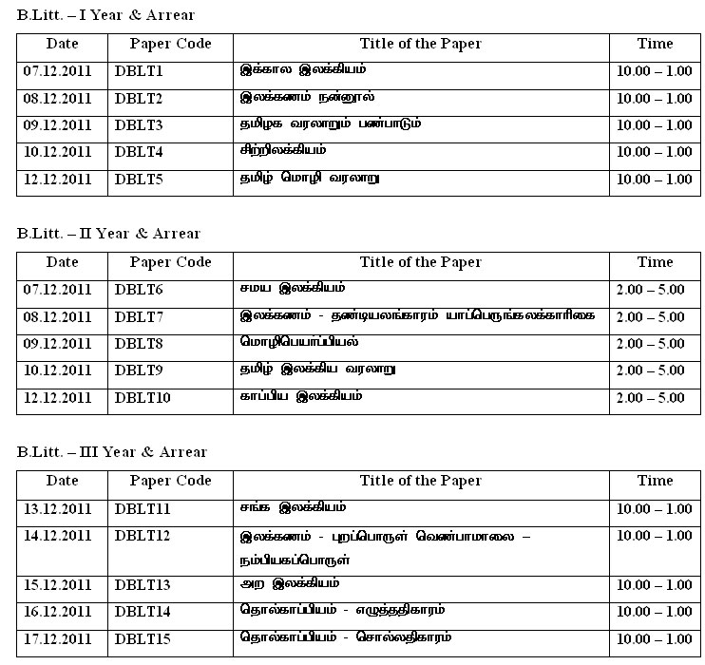
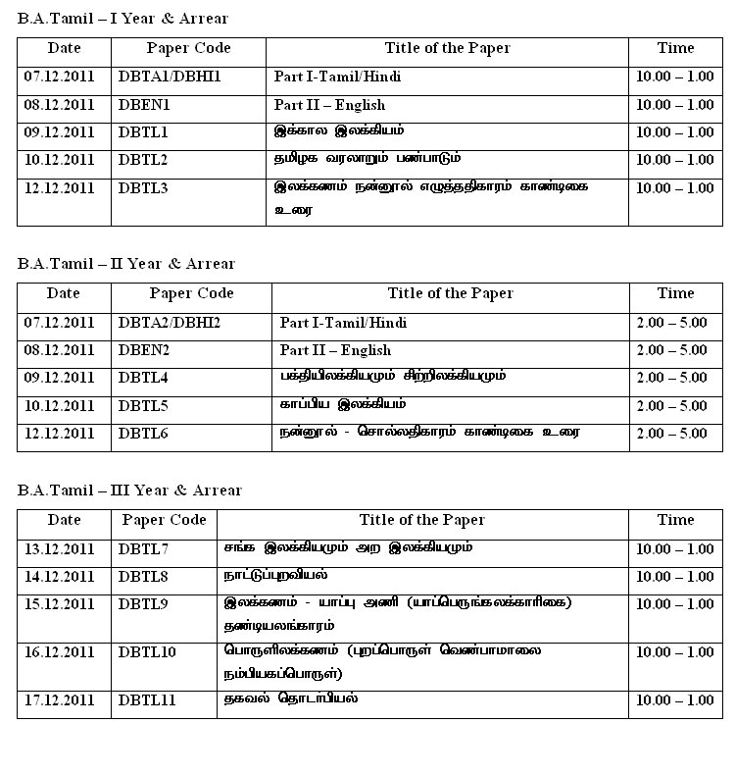

B.Sc. Mathematics – I Year & Arrear
Date | Paper Code | Title of the Paper | Time
07.12.2011 | DBTA1/DBHI1 | Part I-Tamil/Hindi | 10.00 – 1.00
08.12.2011 | DBEN1 | Part II – English | 10.00 – 1.00
09.12.2011 | DBMA1 | Calculus | 10.00 – 1.00
10.12.2011 | DBMA2 | Theory of Equations and Trigonometry | 10.00 – 1.00
12.12.2011 | DBMA3 | Analytical Solid Geometry and Fourier Series | 10.00 – 1.00

B.Sc. Mathematics – II Year
Date | Paper Code | Title of the Paper | Time
07.12.2011 | DBTA2/DBHI2 | Part I-Tamil/Hindi | 2.00 – 5.00
08.12.2011 | DBEN2 | Part II – English | 2.00 – 5.00
09.12.2011 | DBMA4 | Mechanics | 2.00 – 5.00
10.12.2011 | DBMA5 | Statistics | 2.00 – 5.00
12.12.2011 | DBMA6 | Real Analysis | 2.00 – 5.00

Diploma in Soft Skills
Date | Paper Code | Title of the Paper | Time
07.12.2011 | DSS11 | Introduction to Soft Skills | 10.00 – 1.00
08.12.2011 | DSS12 | Personal and Social Skills | 10.00 – 1.00
09.12.2011 | DSS13 | Communication Skills | 10.00 – 1.00
10.12.2011 | DSS14 | Application of Soft Skills | 10.00 – 1.00

Diploma in Career and Educational Counselling
Date | Paper Code | Title of the Paper | Time
07.12.2011 | DEC11 | Foundation of Counselling | 10.00 – 1.00
08.12.2011 | DEC12 | Students Psychology | 10.00 – 1.00
09.12.2011 | DEC13 | Educational Counselling | 10.00 – 1.00
10.12.2011 | DEC14 | Vocational Counselling | 10.00 – 1.00

