APREI SOCIETY, HYDERABAD
CRITERIA OF CALLING CANDIDATES FOR COUNSELING
RAYALASEEMA REGION
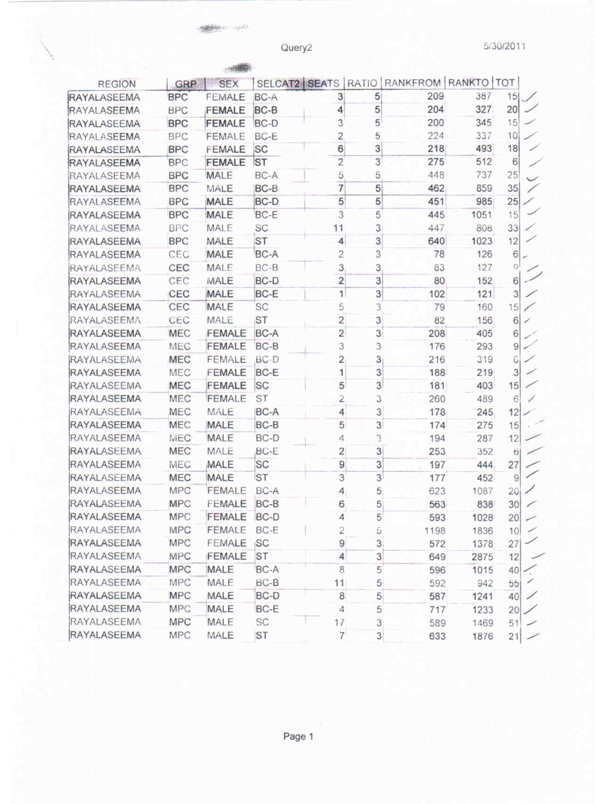
NOTE: GRP:GROUP, SELCAT2: SELECTION CATEGORY , SEATS: AVAILABLE SEATS, RATIO: RATIO IN WHICH CANDIDATES ARE CALLED FOR COUNSELING, RANKFROM: FROM WHICH RANK CANDIDATES ARE CALLED, RANKTO: UPTO WHICH RANK CALLED



