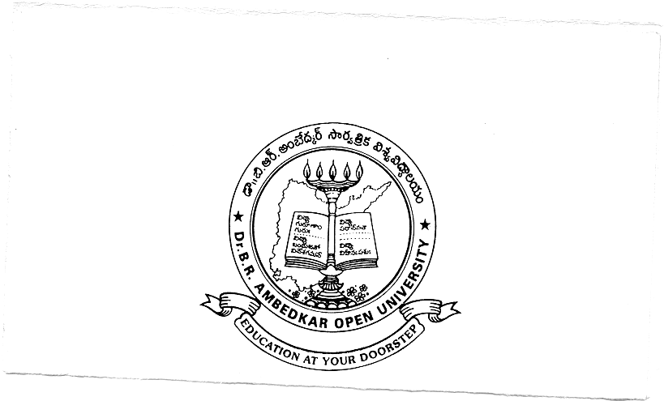
Dr. B.R.AMBEDKAR OPEN UNIVERSITY
Prof. G.Ram Reddy Marg, Road No.46, Jubilee Hills, Hyderabad- 500 033.
www.braou.ac.in
ADMISSION NOTIFICATION 2008–09
MBA, MLISc, MSc, MA, MCom, Ph.D.(ODE), BLISc, BPR, PG DIPLOMA AND CERTIFICATE PROGRAMMES

Dr.B.R.Ambedkar Open University, Hyderabad, invites applications from the eligible candidates for admission into the following programmes for the academic year 2008-09:

Sl.  No. | PROGRAMME | MEDIUM* | DURATION | ELIGIBILITY ** | Code Nos. of Study Centres where prog(s) on offer
1. | Master’s Degree in Business Administration (MBA) | EM | 3 yrs | - Bachelor’s degree in any subject;  - Rank obtained in Integrated Common Entrance Test (ICET)  - Mathematics as one of the subjects in SSC/  SSC Intermediate / Bachelor’s Degree | 002,003,006, 008,009,012, 014, 017,018, 019,021, 023
2. | Master’s Degree in Library and Information Science (MLISc) | EM | 1 yr | B.L.I.Sc Degree (40% marks) | 017,018, 019, 021, 023
3. | M.Sc. - Botany | EM | 2 yrs. | B.Sc. with Botany as one of the optional subjects | 005,017,019, 021, 208
4. | M.Sc. - Chemistry | EM | 2 yrs. | B.Sc. with Chemistry as one of the optional subjects | 005,017,019, 021, 208
5. | M.Sc. – Environmental Science | EM | 2 yrs. | Bachelor’s Degree in Science or its equivalent | 005,017,019, 021, 208
6. | M.Sc. - Physics | EM | 2 yrs. | B.Sc. with Physics & Mathematics as optional subjects | 005,017,019, 021, 208
7. | M.Sc. - Zoology | EM | 2 yrs. | B.Sc. with Zoology as one of the optional subject | 005,017,019, 021, 208
8. | M.Sc. – Mathematics/  Applied Mathematics | EM | 2 yrs. | B.Sc. with Mathematics as one of the optional subjects | 001,002, 003, 005, 006, 007,  008,009, 010, 011, 012,014,  015,016, 017, 018, 019,021,  139
9. | M.A. - Economics | TM | 2 yrs | Bachelor’s Degree with Economics as one of the subjects
10. | M.A. - History | TM | 2 yrs | Bachelor’s Degree in any discipline
11. | M.A. – Political Science | TM | 2 yrs | Bachelor’s Degree in any discipline
12. | M.A. – Public Administration | TM | 2 yrs | Bachelor’s Degree in any discipline
13. | M.A. - Sociology | TM | 2 yrs | Bachelor’s Degree in any discipline
14. | M.A. - English | EM | 2 yrs | Bachelor’s Degree in any discipline
15. | M.A. - Telugu |  | 2 yrs | Bachelor’s Degree in any discipline with Telugu as one of the subjects or equivalent
16. | M.A. - Hindi |  | 2 yr | Bachelor’s Degree in any discipline with Hindi as one of the subjects or equivalent
17. | Master of Commerce ( M.Com) | EM | 2 yrs | Bachelor’s Degree in Commerce/ BBA/ BBM/ B.A(Commerce)
18. | Bachelor’s Degree in Library & Information Science (BLISc) | EM  TM | 1 yr | a)Bachelor’s Degree in any discipline  b) Work experience in Library / CLISc /  50% Marks in Graduation | 002,006, 017, 018, 019, 021, 023
19. | Bachelor’s Degree in Public Relations(BPR) | EM | 1 yr | a)Bachelor’s degree in any discipline  b) Preference to PROs, Journalists and such others working in Media Units of State / Central Govt., Advertising agencies etc. | 002,006, 017, 018, 019, 021, 023
20. | P.G.Diploma in Marketing Management (PGDMM) | EM | 1 yr | Bachelor’s Degree in any discipline | 002,006, 017, 018, 019, 021, 023
21. | P.G.Diploma in Business Finance (PGDBF) | EM | 1 yr | Bachelor’s Degree in any discipline | 002,006, 017, 018, 019, 021, 023
22. | P.G.Diploma in Environmental Studies (PGDES) | EM | 1 yr | Bachelor’s Degree in any discipline | 002,006, 017, 018, 019, 021, 023
23. | P.G.Diploma in Writing for Mass Media in Telugu (PGDWMMT) | TM | 1 yr | Bachelor’s Degree in any discipline OR  Intermediate with 3 years Working experience in  Mass Media | 002,006, 017, 018, 019, 021, 023
24. | P.G.Diploma in Human Rights (PGDHR) | TM | 1 yr | Bachelor’s Degree in any discipline | 002,006, 017, 018, 019, 021, 023
25. | P.G.Diploma in Women’s Studies (PGDWS) | EM | 1 yr | Bachelor’s Degree in any discipline | 002,006, 017, 018, 019, 021, 023
26. | Certificate Programme in Food & Nutrition (CPFN) | TM | 6mon-ths | - No formal academic qualification  - Minimum age : 18 years | 002, 006, 017, 018, 019, 021, 023
27. | Ph.D. Programme in Open Distance Education (offered by GRADE, Dr.BRAOU):  Eligibility Criteria:.i) Candidates with M.Phil. or Ph.D. degree in any subject OR ii) High Second class (secured not less than 55%) Master’s Degree in any subject with at least 2 research publications in Distance Education in the Journals recommended by the University OR iii) High second class Masters Degree in any subject with one research publication in Distance Education and 3 years experience in any Distance Education Institution OR iv) High Second class Masters Degree in Distance Education (MADE) with atleast one research publication in Distance Education or 3 years experience in Distance Education.  * Note: Your Research publications will be considered only if they are published in the journals recommended by the University (see http://www.braou.ac.in/ for details).
* EM – English Medium; T.M. – Telugu Medium ** For details see Prospectus
STUDY CENTRES AND THEIR CODE NUMBERS:
(001) Govt. Degree College, Adilabad; (002) Govt.Degree College, Ananthapur; (003) Govt. Deg. College, Kadapa; (005) JKC College, Guntur; (006) SRR Govt.Deg.College, Karimnagar; (007) SR&BGNR Govt. College, Khammam; (008) Silver Jubilee Govt. College, Kurnool; (009) MVS Arts & Sci.College, Mahaboobnagar; (010) Nagarjuna Govt. Deg. College, Nalgonda; (011) Sri Sarvodaya College, Nellore; (012) Girraj Govt. College, Nizamabad; (014) Govt. Degree College, Rajahmundry; (015) Govt. Deg. College, Siddipet; (016) Govt. Degree College, Srikakulam; (017) S.V.Arts College, Tirupati; (018) P.B.Siddartha College, Vijayawada; (019) Dr.V.S.Krishna Govt. Deg. College, Visakhapatnam; (021) University Arts & Science College, Subedari, Warangal; (023) R.G. Kedia College of Commerce, Chaderghat, Hyderabad; (139) Sardar Patel College, Padmarao Nagar, Secunderabad and (208) STML Building, Dr.BRAOU, Road No.46, Jubilee Hills, Hyderabad.
COST OF APPLICATION FORM: (a) Programmes at Sl.No.1 to 7 -- Rs.200/-; (b) Sl.No.8 to 17 -- Rs.100/-; (c) Sl.No.18 to 25 – Rs.50/-; (d) Sl.No.26 -- Rs.20/-; (e) Sl.No. 27 – Rs.150/-.
For obtaining Application Forms DD should be drawn in favour of THE REGISTRAR DR.BRAOU, HYDERABAD With Candidates Name on any Nationalized Bank for respective amounts. Cash will not be accepted.
HOW TO OBTAIN APPLICATION FORM: In Person: Application forms can be obtained by submitting DD between 11.00 AM and 4.30 PM from the University Headquarters at Road No.46, Jubilee Hills, Hyderabad – 500 033 on all working days OR at the study centres mentioned against each programme between 11.00AM and 4.30 P.M. on all working days except Mondays and Tuesday immediately following the Second Saturday.
By Post: The application can also be obtained from the Director, Student Services Branch, Road No.46, Jubilee Hills, Hyderabad - 500 033 by sending a crossed Demand Draft for the cost of the application form plus Rs.30/- towards postage.
Ph.D.(ODE): The application form can be obtained from the office of the Director, GRADE, Dr.BRAOU, Road No. 46, Jubilee Hills, Hyderabad by submitting a DD for Rs. 150/-. The application form can also be obtained by post from the Director, GRADE, Dr.BRAOU, Road No.46, Jubilee Hills, Hyderabad 500033 by sending a crossed DD for Rs. 200/-. The application forms of Ph.D. (ODE) programme may also be downloaded from the University Website (http://www.braou.ac.in/grade). However the filled in downloaded form should be submitted along with a crossed DD for Rs. 150/- to the Director, GRADE.
Commencement of the Sale of Application Forms : 30-07-2008
LAST DATE FOR SALE AND SUBMISSION OF FILLED IN FORMS: With late fee of Rs. 100/-
a) For MBA, MLISc, BLISc, & PG Diploma programmes : 20.08.2008 03-10-2008
b) For other Programmes : 27.08.2008 03-10-2008
The filled in application forms of all programmes should be submitted at the respective study centres. However, the application forms of MBA, MLISc. BLISc, BPR, CPFN and PG Diploma Programmes should be submitted in person at the University Campus or by post to the Director, Student Services Branch, Dr.B.R.Ambedkar Open University, Road No.46, Jubilee Hills, Hyderabad – 500 033.
Note:
- Students who completed MBA with One Specialization from Dr.BRAOU and wish to do it with another specialization can obtain application form from their respective Study Centres by submitting a crossed DD for Rs. 100/- drawn on any Nationalized Bank in favour of “The Registrar, Dr.BRAOU, Hyderabad with the name of the student”. Last date for sale & submission of application form is 30.08.2008.
- Students who couldn’t complete the programme within the maximum period prescribed and wish to take re-admission are requested to obtain the details from the head quarters. Readmission will be given as per the rules and regulations of the University Sd/-

REGISTRAR

